**NON-FUNCTIONAL REQUIREMENT** (NFR) specifies the quality attribute of a software system. They judge the software system based on Responsiveness, Usability, Security, Portability and other non-functional standards that are critical to the success of the software system. Example of nonfunctional requirement, *“how fast does the website load?”* Failing to meet non-functional requirements can result in systems that fail to satisfy user needs.

Non-functional Requirements allows you to impose constraints or restrictions on the design of the system across the various agile backlogs. Example, the site should load in 3 seconds when the number of simultaneous users are> 10000. Description of non-functional requirements is just as critical as a functional requirement.

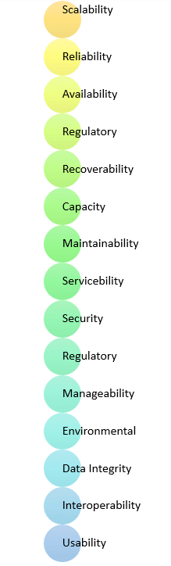

* Usability requirement
* Serviceability requirement
* Manageability requirement
* Recoverability requirement
* Security requirement
* Data Integrity requirement
* Capacity requirement
* Availability requirement
* Scalability requirement
* Interoperability requirement
* Reliability requirement
* Maintainability requirement
* Regulatory requirement
* Environmental requirement

**Advantages of Non-Functional Requirement**

Benefits/pros of Non-functional testing are:

* The nonfunctional requirements ensure the software system follow legal and compliance rules.
* They ensure the reliability, availability, and performance of the software system
* They ensure good user experience and ease of operating the software.
* They help in formulating security policy of the software system.

**Disadvantages of Non-functional requirement**

Cons/drawbacks of Non-function requirement are:

* None functional requirement may affect the various high-level software subsystem
* They require special consideration during the software architecture/high-level design phase which increases costs.
* Their implementation does not usually map to the specific software sub-system,
* It is tough to modify non-functional once you pass the architecture phase.

**KEY LEARNING**

* A non-functional requirement defines the performance attribute of a software system.
* Types of Non-functional requirement are Scalability Capacity, Availability, Reliability, Recoverability, Data Integrity, etc.
* Example of Non Functional Requirement is Employees never allowed to update their salary information. Such attempt should be reported to the security administrator.
* Functional Requirement is a verb while Non-Functional Requirement is an attribute
* The advantage of Non-functional requirement is that it helps you to ensure good user experience and ease of operating the software
* The biggest disadvantage of Non-functional requirement is that it may affect the various high-level software subsystems.